Submitted By: Aiman Ismail

Summary of “Unveiling the Black Box: A Systematic Review of Explainable Artificial Intelligence in Medical Image Analysis”
Link: https://spj.science.org/doi/10.1016/j.csbj.2024.08.005
Artificial Intelligence and deep learning are increasingly being used in medical imaging to help detect and classify diseases. Deep learning models, especially Convolutional Neural Networks (CNNs), can learn complex patterns from medical images and often achieve high accuracy. However, one major problem with these models is that they are often considered “black boxes.” This means that although the model can give a prediction (yes or no), it is difficult for humans to understand exactly why it made that decision. This problem is especially important in healthcare because doctors need to trust and understand the results before using AI in medical decision-making.
The paper discusses the importance of Explainable Artificial Intelligence (XAI) in medical image analysis. XAI refers to techniques that help explain the decisions made by AI models. Instead of simply predicting that a patient has a disease, an explainable model can provide information about the features or regions of an image that influenced its prediction. For example, in a chest X-ray, an explanation method may highlight a specific region of the lungs that contributed to a prediction of pneumonia.
The paper discusses several XAI techniques used in medical imaging. Some important methods include LIME, SHAP, CAM, and Grad-CAM. LIME explains individual predictions by examining the importance of different parts of an input. SHAP explains how different features contribute to a model's output. CAM and Grad-CAM are particularly useful for medical images because they can create heatmaps showing the areas that were most important for the model's decision. These visual explanations can help doctors compare the AI's reasoning with their own medical knowledge.
However, the paper also explains that XAI methods have some limitations. Some methods require a large amount of computational power and can be slow when working with complex medical images. Also, an explanation generated by an AI system is not always guaranteed to represent the true reasoning of the model. Some explanations can also be difficult for non-technical users to understand. Therefore, XAI methods need to be carefully evaluated to make sure that their explanations are reliable and useful.
The paper concludes that explainability is very important for the future of AI in medical imaging. A highly accurate AI model is not always enough, especially in healthcare. Doctors and other medical professionals need to understand why a model has made a particular prediction. The future of medical AI should therefore focus on developing systems that are both accurate and explainable. Overall, XAI can improve transparency, trust, and the practical use of AI in medical diagnosis. This is especially relevant to medical imaging projects where a model can provide a prediction along with a heatmap and a simple explanation of the areas that influenced its decision.

What I Learned
These Python programs helped me understand how to work with image datasets. I practiced using the os module to access folders and read the image files stored inside different class folders. I also understood how to count the number of images in each class and check the size of a dataset.
Using Matplotlib, I created a bar chart to show the distribution of images among different classes. This helped me understand whether the dataset is balanced or if one class has more images than another. I also practiced displaying multiple images in a grid and opening images using the PIL library.
Overall, these programs gave me a basic understanding of how image datasets are handled before training a machine learning or deep learning model.

Python Programs:
Program 1:
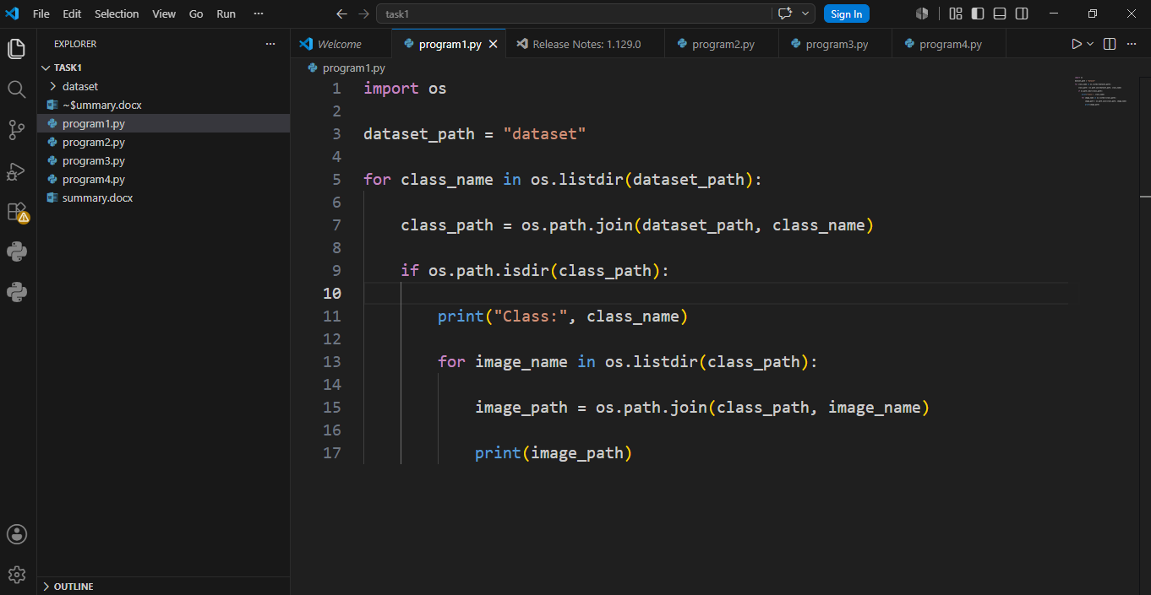
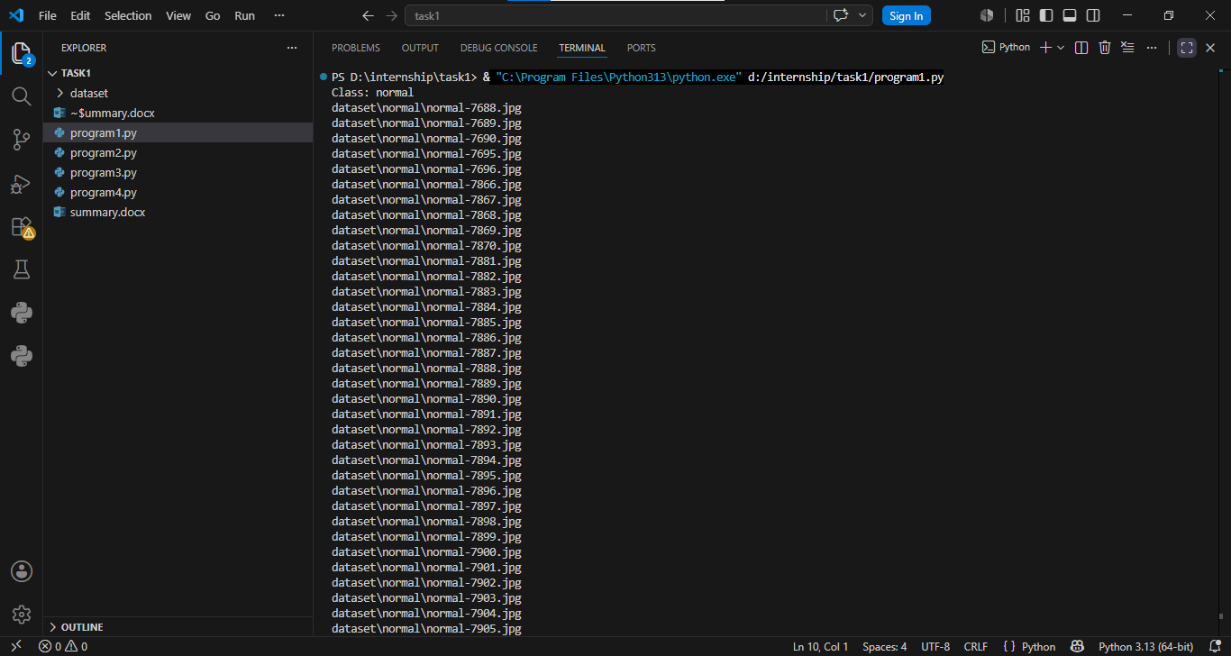
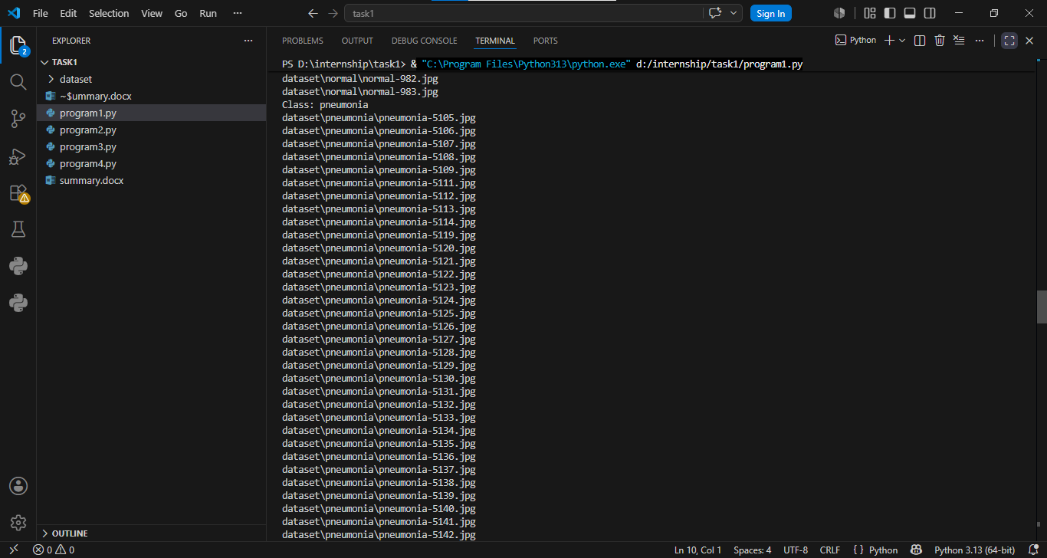
Program 2:
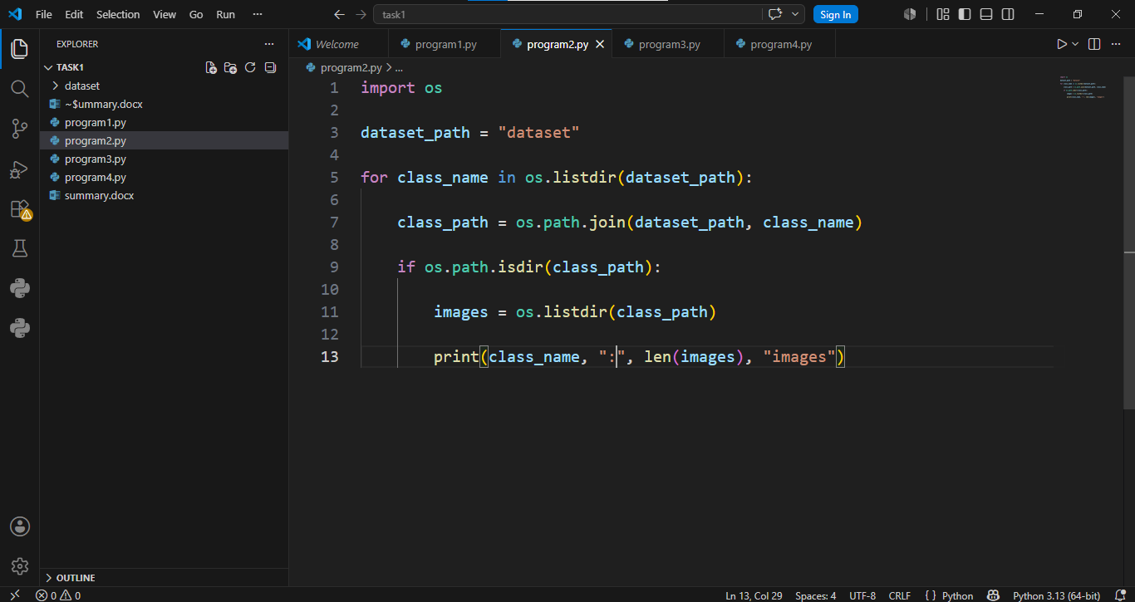
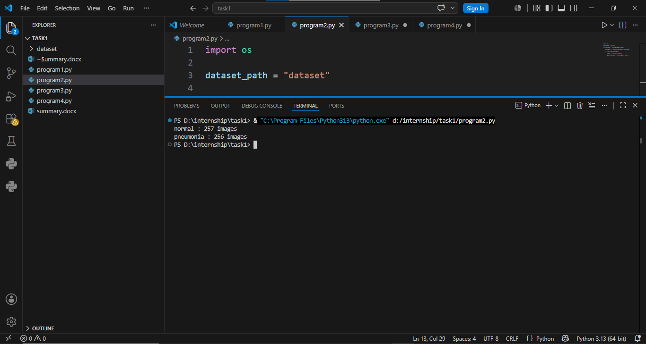

Program 3:
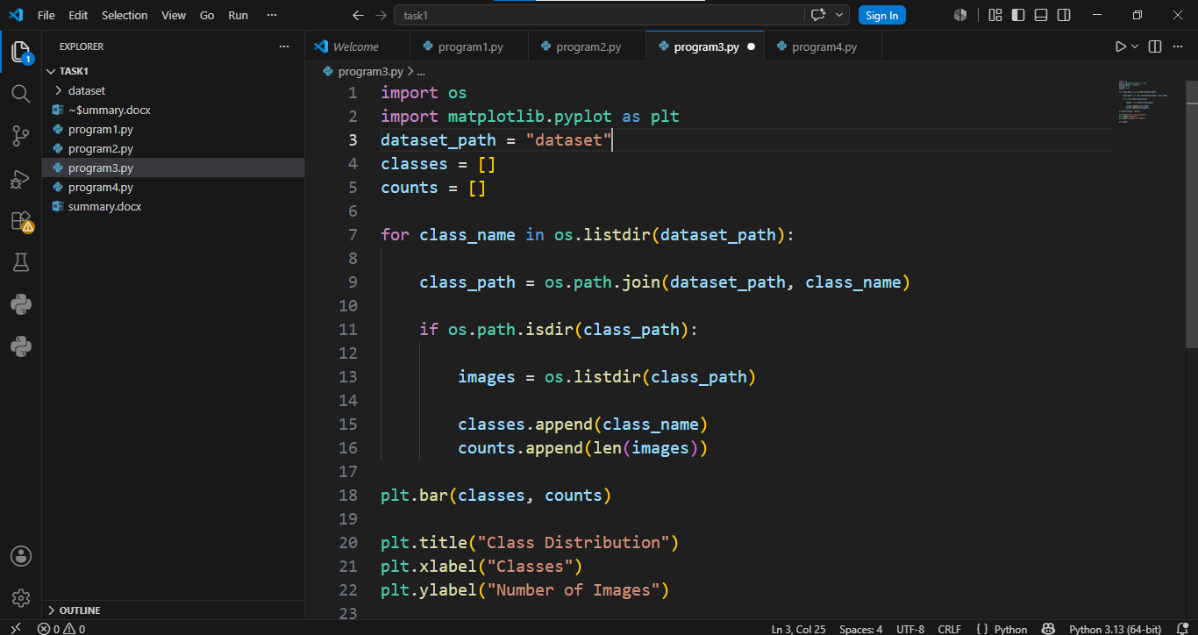
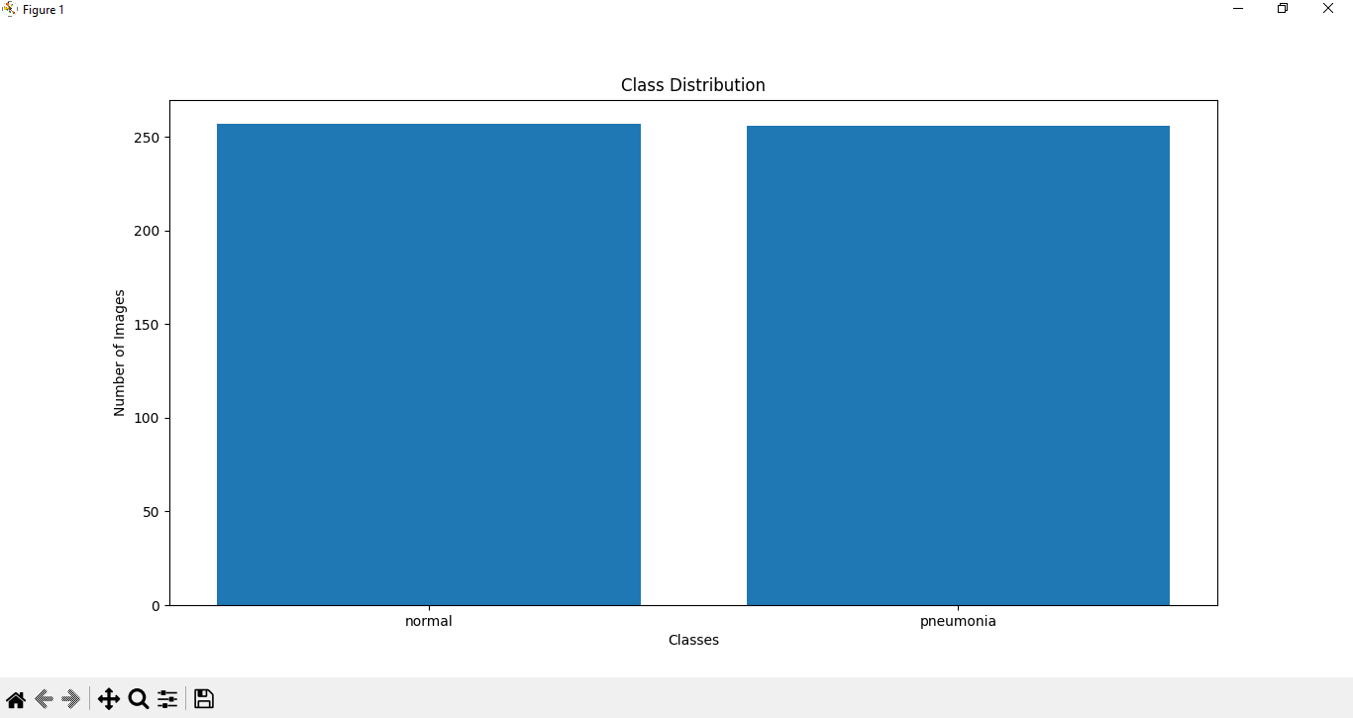
Program 4:
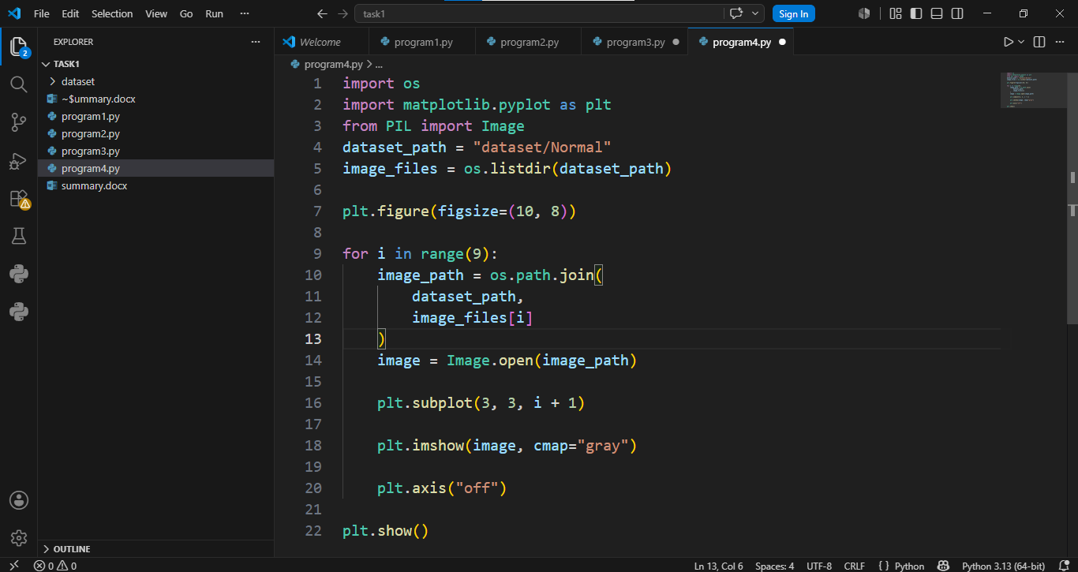
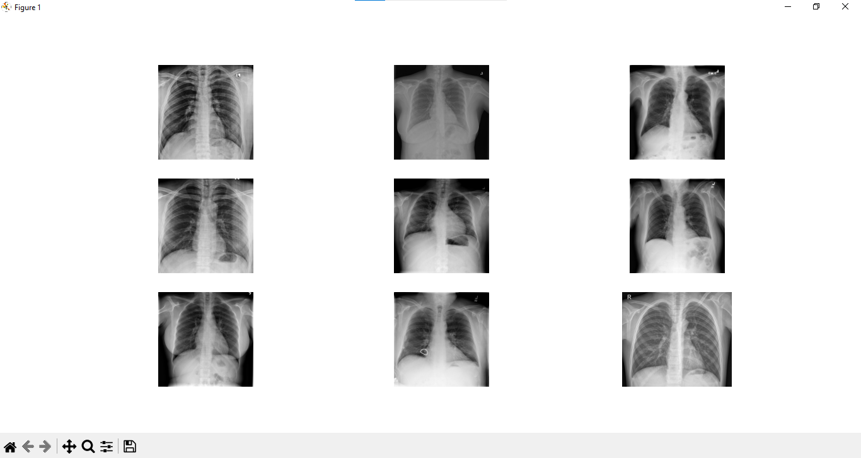

END

